**Applied Data Science Capstone**

*Final Project*

*The Battle of Neighborhoods*

**Exploring New York City - Manhattan**

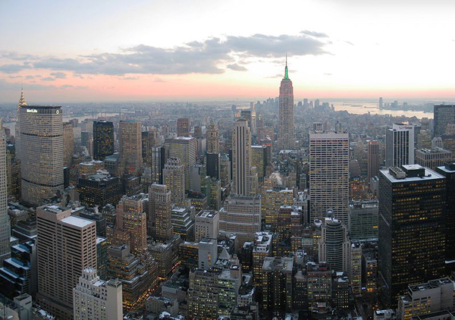

By: Dawn Tran

12/05/2020

1. **Introduction**

New York City – the city that never sleep, often called as New York, is the most populous and dense city in the United States. Situated on one of the world’s largest natural harbors, New York City is the composed of five boroughs – Brooklyn, Queens, Manhattan, Bronx and Staten Island. Based on the record – 62.7 million tourists visited New York City in 2017, especially Manhattan, attracted a large volume of tourists and visitors from all over the world every year. Beside the most known places like: Times Square, Broadway Theater District, Rockefeller Center, and Wall Street, there are many places and things to do or to visit in New York City. Often, the first timer visiting New York City will need a guidance for choosing a place to stay, places to visit, places to shop and etc…

1. **Business Problem**

Due to this demand and the growth of the travel accommodation, Travel agency starting a project of preparing a list of hotels, restaurants, coffee shops along with the name, address, location and the map for their clients. So that their clients can be prepare and know to what to do and where to go when they arrived in New York City – the City that never sleep.

This project is particularly useful for those visitors / tourists that is the first-time visiting New York City or a re-visit after many years.

1. **Target Audience**

This project is targeting for Tourists that are not familiar with or never been to New York City before.

1. **Data**

To get all this information, we will need the following data:

* New York City data containing the Neighborhoods and boroughs along with latitude and longitude coordinates. This is required to plot the map and get the venue data.
* Venue data for hotels, restaurants, coffee shops, so that we can analysis and explore Manhattan of New York City

Data Sources that are using to extract this information

* New York City data with latitude and longitude coordinates can be found by using the source from the module 3 in this course:

<https://cocl.us/new_york_dataset> (newyork_data.json)

* Use Foursquare API to get the venue data for the neighborhoods. Foursquare API provides many categories of the venue data that we needed for this project such as; hotel, food, places to visit and etc…
* This project will be required using of web scrapping (open source dataset), working with Foursquare API, data cleaning, data wrangling, map visualization by using Folium and plotting the map with matplotlib.
* Will define all the detail data analysis in the next section – Methodology

1. **Methodology**

In this project, we are trying to explore Manhattan’s neighborhoods, put together a list of hotels, restaurants and coffee shops along with name, address and their latitude and longitude.

First step: we have to collected list of data of the neighborhoods along with latitude and longitude in New York City from <http://cocl.us/new_york_dataset>. And extract Manhattan neighborhood information put it in to a dataframe.

Second step is to use the FourSquare API to locate all venues and filter out by hotels, restaurants and coffee shops that are within 1000 meter around Manhattan area

Final step is the data be put in dataframe and be able to visualize through a map

1. **Results**
2. Getting neighborhoods information for Manhattan area along with Latitude and longitude

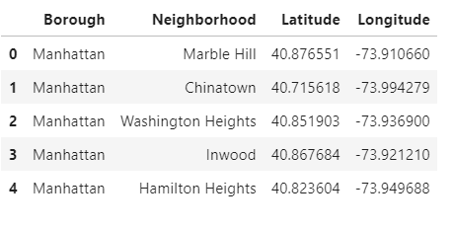

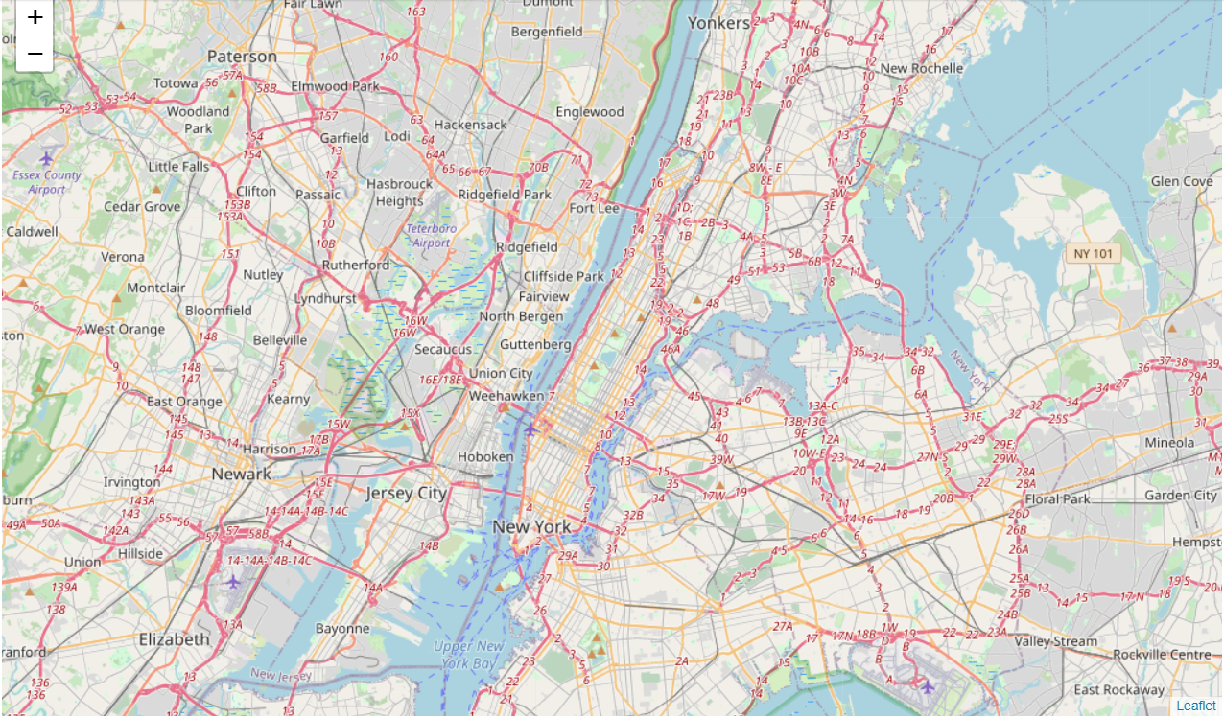

1. Collected a list of hotels by within 1000 meters around Manhattan area. Put it in a data frame and able to visualize it through a map

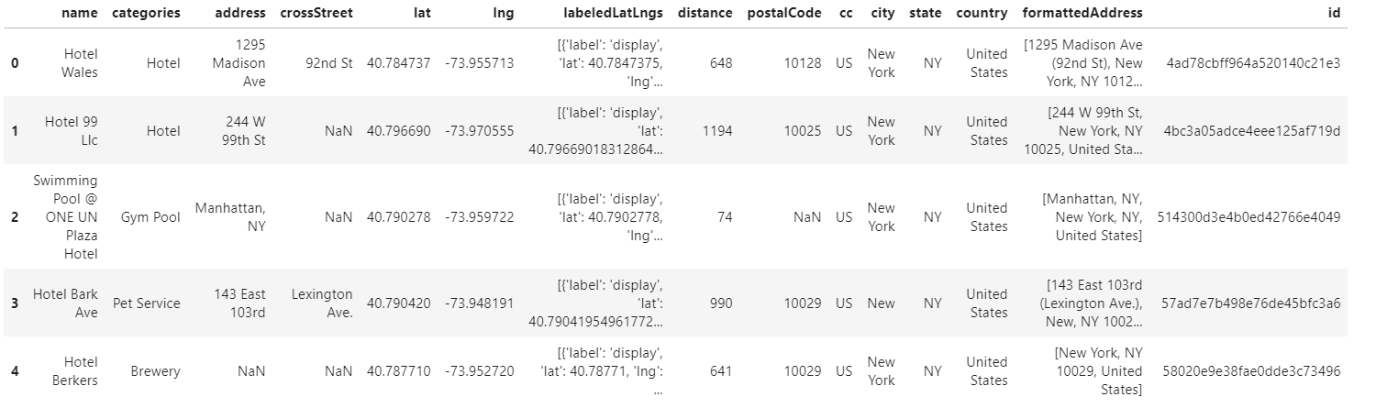

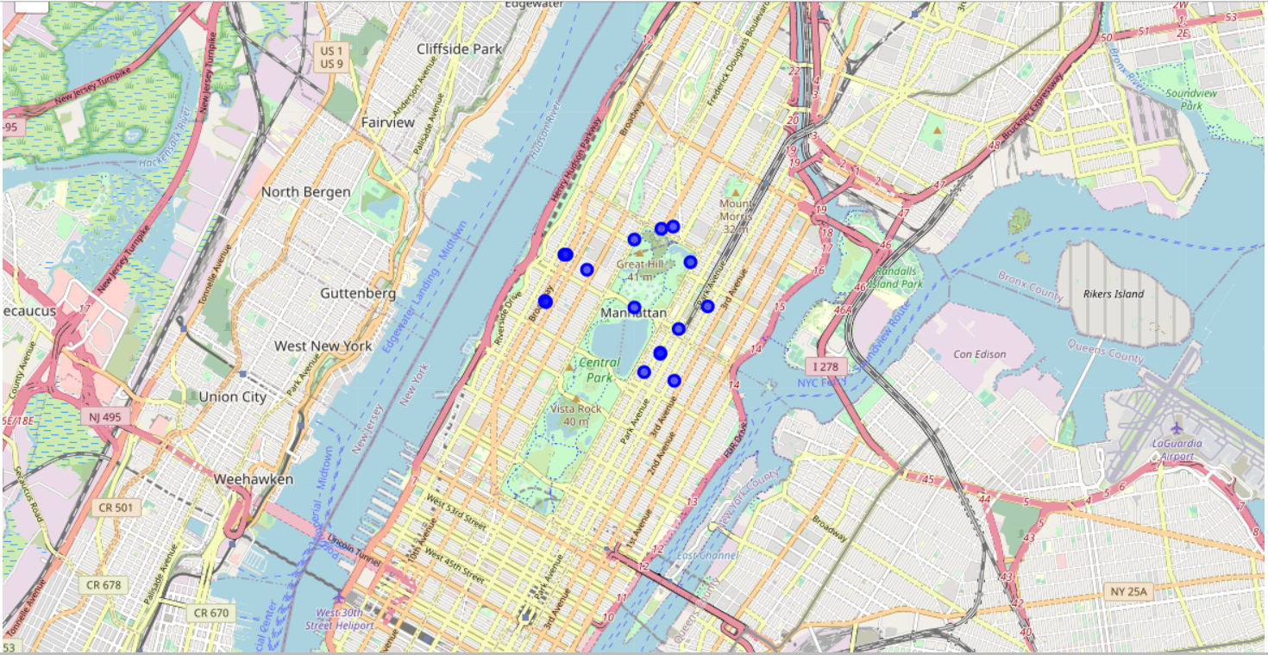

1. Collected a list of restaurants within 1000 meters around Manhattan’s area, put it into a dataframe and then visualized it through a map

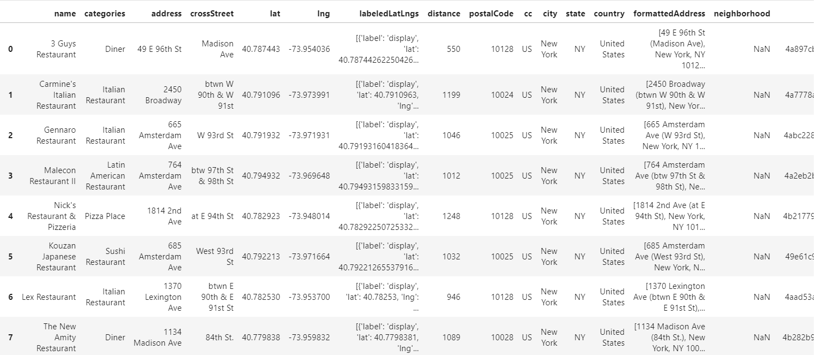

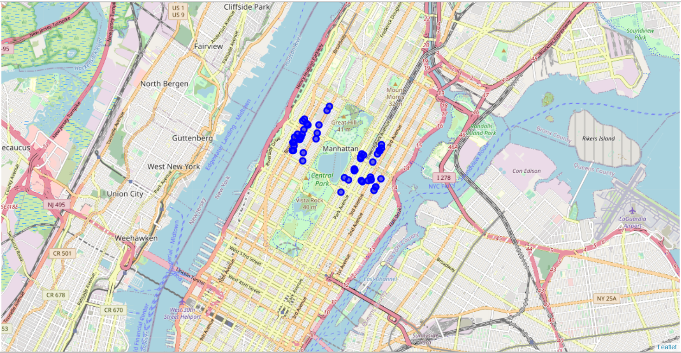

1. Collected a list of coffee shops within 1000 meters around Manhattan’s area, put it into a dataframe and then visualized it through a map

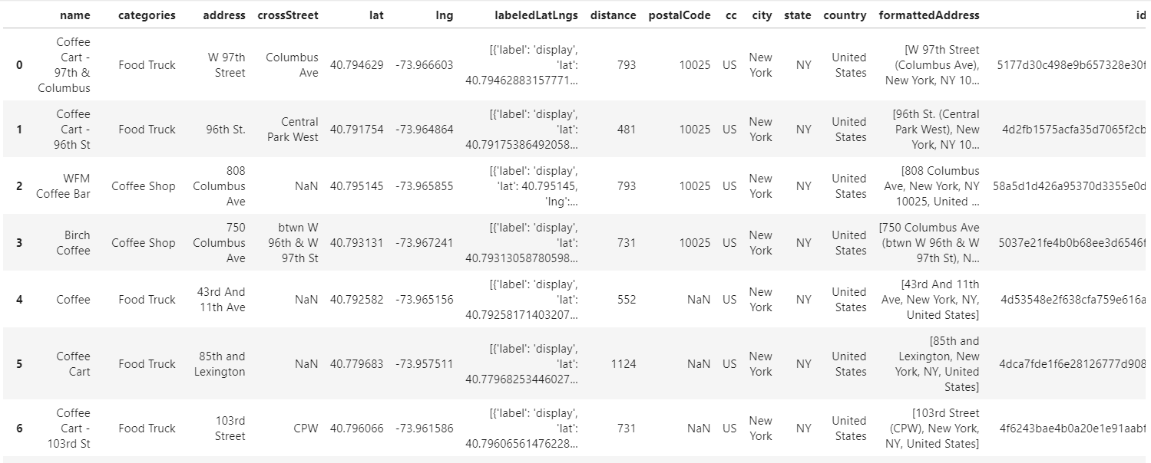

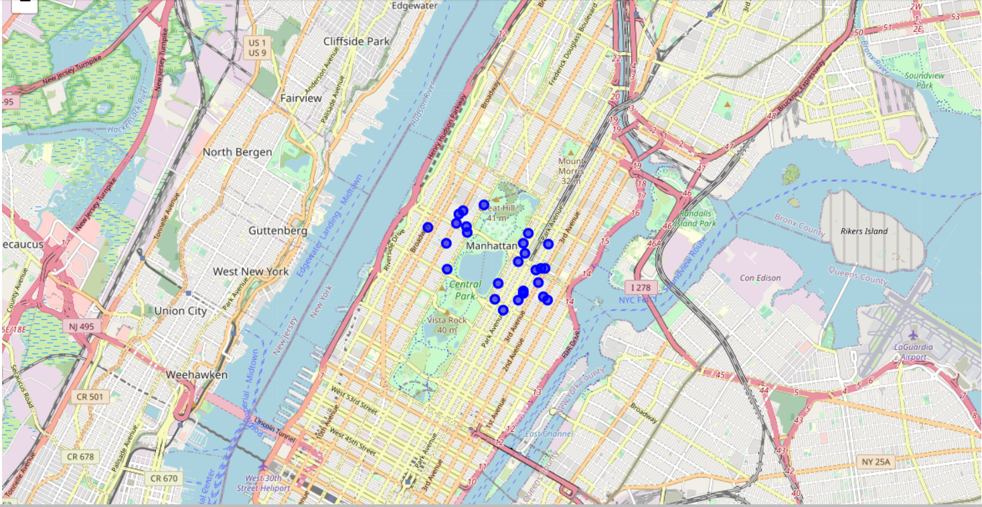

1. **Results and Discussion**

Based on the results from collecting all the data by using FourSquare API,

* 16 Hotels were found within 1000 meters of the Manhattan, New York City area
* 50 Restaurants were found within 100 meters around Manhattan, they are all different variety and diversity of the food chains to choose from, such as Japanese, Mexican, Chinese, Italian and etc..
* 27 Coffee shops were found within 100 meters of Manhattan area

With all these choices, tourists will be able to book a hotel to stay, or have no problem of looking for a restaurant to enjoy a meal when they are hungry, or enjoy a cup of coffee while they are exploring the beauty around Manhattan, New York city.

1. **Conclusion**

New York City, especially Manhattan is a great place for vacation, not only there are plenty of places to visit and to see. Also, there are many choices of hotels, restaurants and coffee shops for tourists to choose from. They are very convenient, all within walking distance.

With these data, travel agents be able to provide all the information to their clients prior to their trip. Hence, tourists can be able to save some time and efforts from searching information on their own and be able to enjoy their stay and have a great time visiting Manhattan, New York City.